Create a Employee Collection add 5 documents:

Example:

{emono:111,ename:”Deepali

Vaidya”,sal:40000.00,dept:{deptno:12,dname:,”Hr”,dloc:”Mumbai},

Desg:”Analyst”,mgr:{name:”Satish”,num:111},project:[{name:”Project-

1”,Hrs:4},{name:”project- 2”,Hrs:4}]}



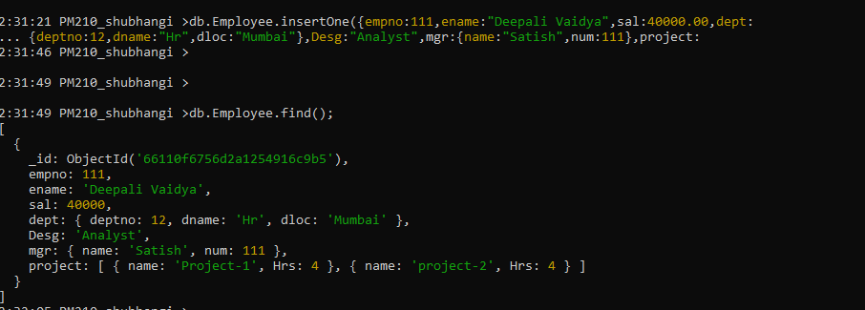

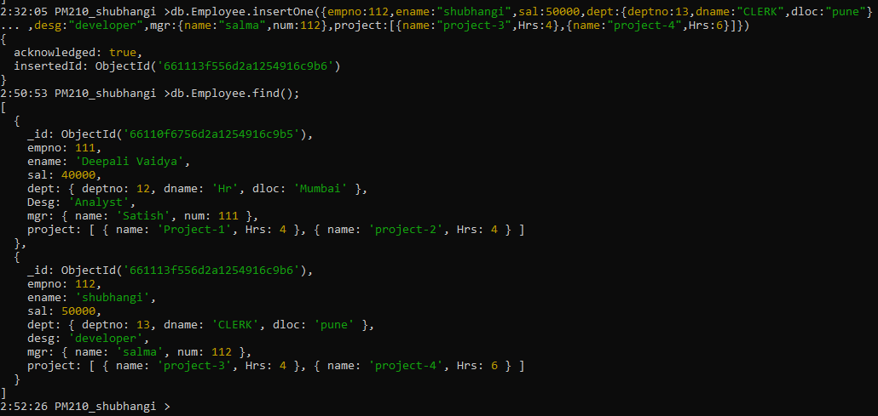

1. All Employee’s with the dname as ‘CLERK’ are now called as (AO) Administrative Officers.

Update the Employee collection for this. 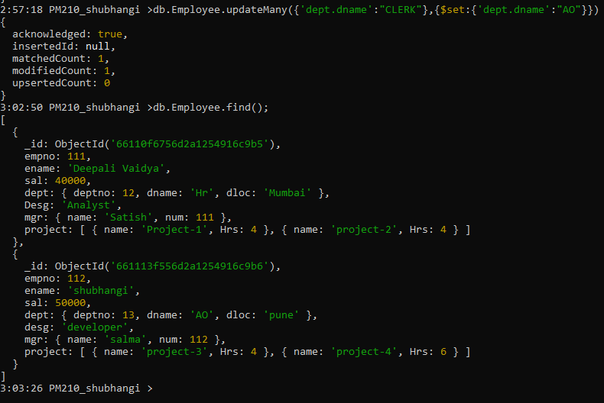

2. Change the number of hours for project-1 to 5 for all employees with designation analyst.

2. Change the number of hours for project-1 to 5 for all employees with

designation analyst.

db.Employee.updateMany({desg:'Analyst','project.0.Hrs':4},{$set:{'project.0.Hrs':5}})

db.Employee.updateMany({desg:'Analyst'},{$set:{'project.0.Hrs':5}})

3. Add 2 projects project-3 and project-4 for employee whose name starts with ”Deep” with 2 hrs

$push:{project:$each:['project-5','project-6']}

db.Employee.updateMany({name:/^Deep/},{$push:{project:{$each:[{name:'project-5',Hrs:2},{name:'project-6',Hrs:7}]}}},{multi:true})

db.Employee.update({name:/^Deep/},{$push:{project:{$each:[{name:'project-3',Hrs:2},{name:'project-4',Hrs:2}]}}},{multi:true})

3. Add 2 projects project-3 and project-4 for employee whose name starts with ”Deep” with 2 hrs

db.emp.update({name:/^Deep/},{$push:{project:{$each:[{name:'project-

3',Hrs:2},{name:'project-4',Hrs:2}]}}},

{multi:true})

4. Add bonus rs 2000 for all employees with salary > 50000

5. add bonus 1500 if salary <50000 and > 30000

6. add bonus 1000 if salary <=30000

7. Change manager name to Tushar for all employees whose manager is currently “satish”

And manager number to 3333

8. Increase salary of all employees from “purchase department” by 15000

9. Decrease number of hrs by 2 for all employees who are working on project-2

10. Delete project-2 from all employee document if they are working on the project for 4

hrs.

db.emp.update({},{$pull:{“project.name”:”project-

2”,”project.Hrs”:4}},{multi:true})

or

db.Emp.update({},{$pull:{project:{name:'project-2',Hrs:4}}},{multi:true})

or

db.emp.update({},{$pull:{“project:{$elemMatch:{name:”project-

2”,”Hrs”:4}},{multi:true})

11. Change the salary of employees to 10000 only if their salary is < 10000

12. Increase bonus of all employees by 500 if the bonus is <2000 or their salary is <

20000 or if employee belong to sales department

13. Add 2 new project at position 2 for all employees with designation analyst or salary is

equal to either 30000 or 33000 or 35000

14. Delete last project of all employees with department name is “HR” and if the location

is Mumbai

15. Change designation of all employees to senior programmer if they are working on

name:”Project-1” for 4 hrs

16. Add list of hobbies in all employees document whose manager is Rajan or Revati

17. Add list of skillset in all employee documents who are working on project-4 for 3 hrs

or on project-3 for 4 hrs

18. Add a new hobby as blogging at 3 position in hobbies array for all employess whose

name starts with R or p and ends with j or s

19. Increase salary by 10000 for all employees who are working on project-2 or project-3

or project-1

20. Decrease bonus by 1000 rs And increase salary by 1000rs for all employees whose

department location is Mumbai

21. Remove all employees working on project-1

22. Replace document of employee with name “Deepak to some new document

23. Change skill python to python 3.8 for all employees if python is there in the skillset

24. Add 2 skills MongoDb and Perl at the end of skillset array for all employees who are

working at Pune location

25. Delete first hobby from hobby array for all employees who are working on project-1

or project-2

26. Delete last hobby from hobbies array for all employees who are working on project

which is at 2 nd position in projects array for 4 hrs

27. Add 2 new projects at the end of array for all employees whose skillset contains Perl

or python

28. Change hrs to 6 for project-1 for all employees if they working on the project-1 for <

6 hrs. otherwise keep the existing value.